An Efficient Vote Casting System with Aadhar Verification through Blockchain
Traditional voting system in India often fall prey to bogus voting and to combat against this bogus voting EVM has been deployed but EVM database can be easily tamper. In propose paper author employing Blockchain along with IOT cloud connection to avoid EVM tampering.
Blockchain has inbuilt support for secured (encrypted) and tamper proof data storage which can be utilize to capture voter fingerprint and then matched with Aadhar fingerprint cloud database, if user fingerprint authenticated then only EVM will accept user vote. EVM will utilize IOT network to forward voting count details to centralized cloud server. IOT network cannot be easily hack so fully security will be provided to avoid any type of network attack.
Blockchain can store and retrieve data with the help of Smart Contracts which can be designed using Solidity programming. Smart contract contains functions which can be called with any programming language. To manage candidate and voter details we have designed following contract
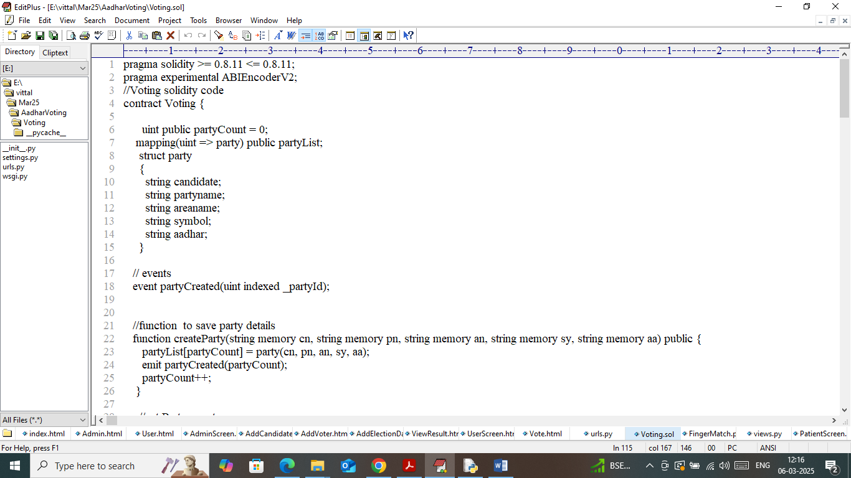
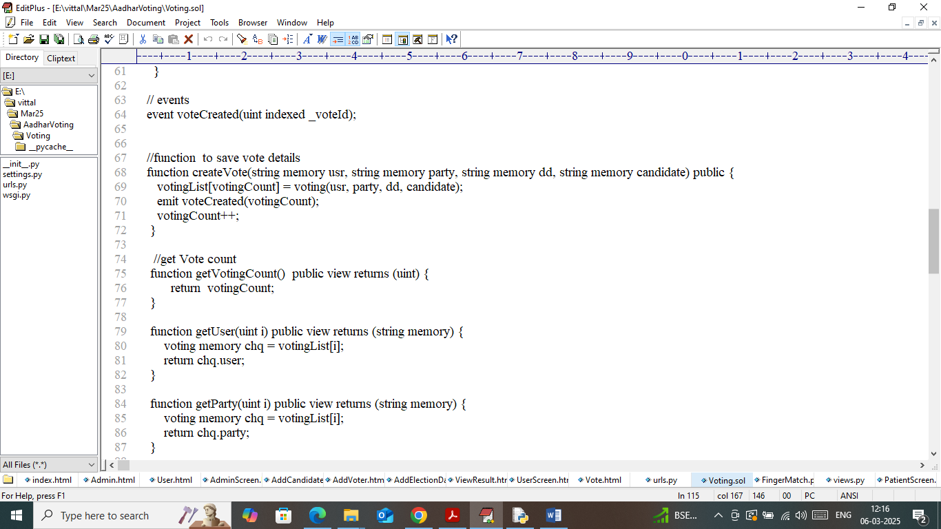
In above smart contract code we have defined required functions to manage candidate, voter and verification or tally functions. Now we need to deploy above contract to Blockchain Ethereum using below steps
- First go inside ‘hello-eth/node-modules/bin’ folder and then look and double click on ‘runBlockchain.bat’ file to start Ethereum and get below page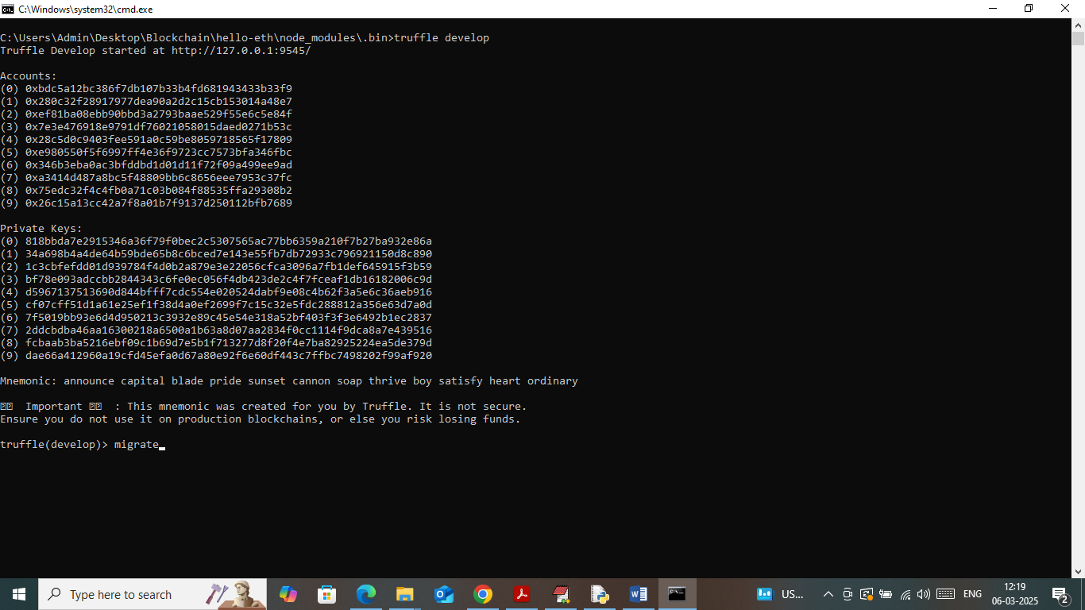
- In above screen Ethereum started with default accounts and private keys and now type command as ‘migrate’ and then press enter key to get below page
- 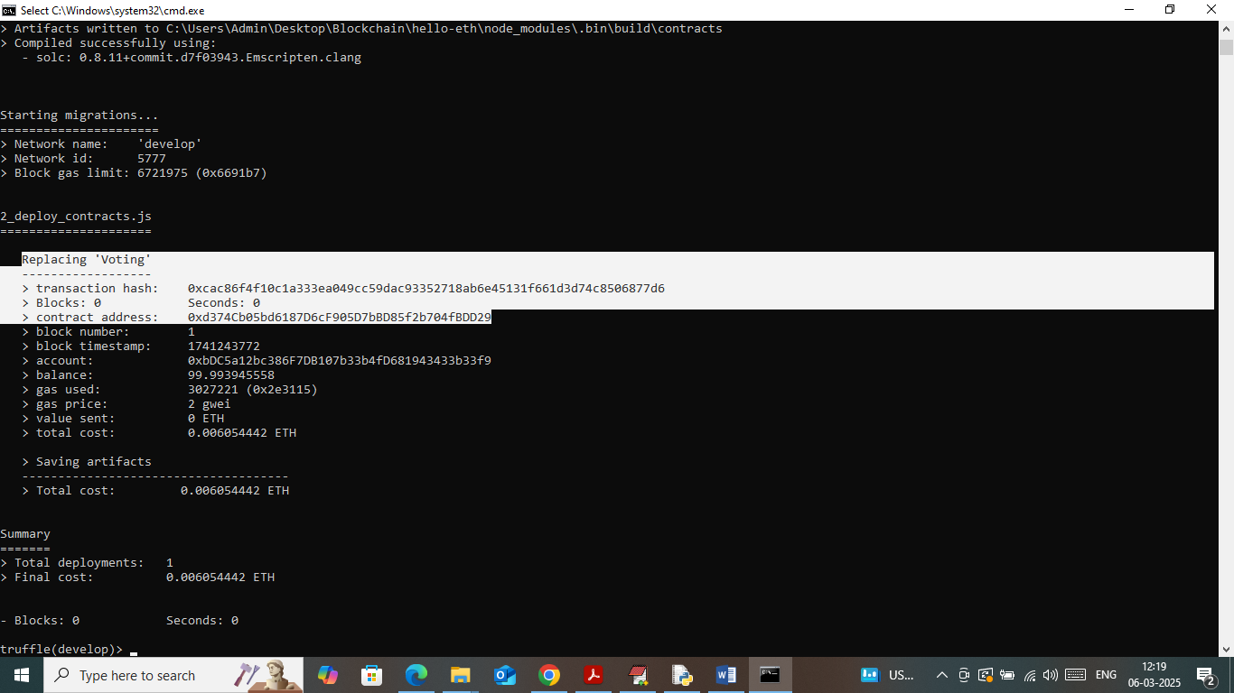
- In above screen in white colour text can see ‘Voting’ contract deployed and running successfully. Let the above console running till you executed code. All candidates and voter data will be saved in above EVM Blockchain memory.
Modules Information
To implement this project we have designed two modules which consists of two different users such as ‘Admin and Voter’.
- Admin Login: admin can login to system using username and password as admin and admin
- Candidate Registration: after login admin will add candidate details
- Voter Registration: using this module admin will add voter details by taking finger and Aadhar details and this data will be saved in Cloud Blockchain server
- Add Election Date: using this module admin will add election date
- View Vote Count: using this module admin can view number of voted secured by each candidate
- User Login: whenever voter comes to cast vote then EVM will display Login page along with fingerprint image to upload. EVM will tally/matched user finger with Cloud Aadhar finger database. Once fingerprint authenticated EVM will forward user to cast vote. Each user allowed to cast vote only one time
- View Result: voter can view number of votes secured by each candidate
- Latency Graph: using this module will plot Blockchain Latency graph which take time to verify voters.
SCREEN SHOTS
To run project double click on ‘run.bat’ file to get below page
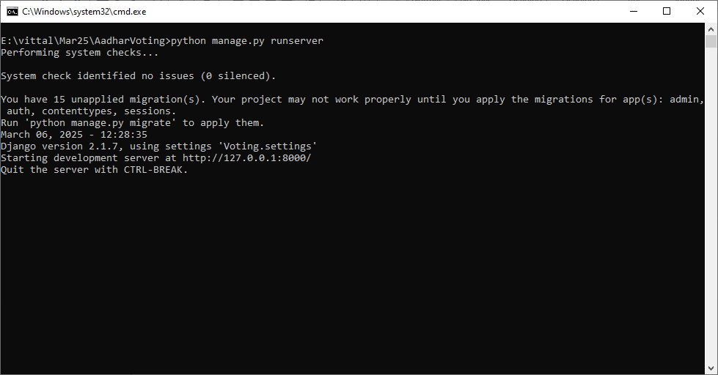
In above screen python web server started and now open browser and enter URL as http://127.0.0.1:5000 and then press enter key to get below page
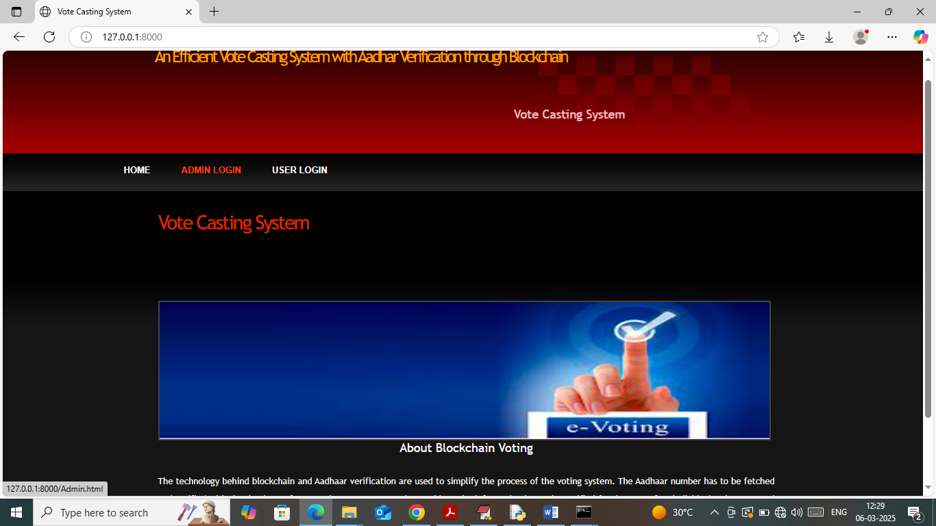
In above screen click on ‘Admin Login’ link to get below page
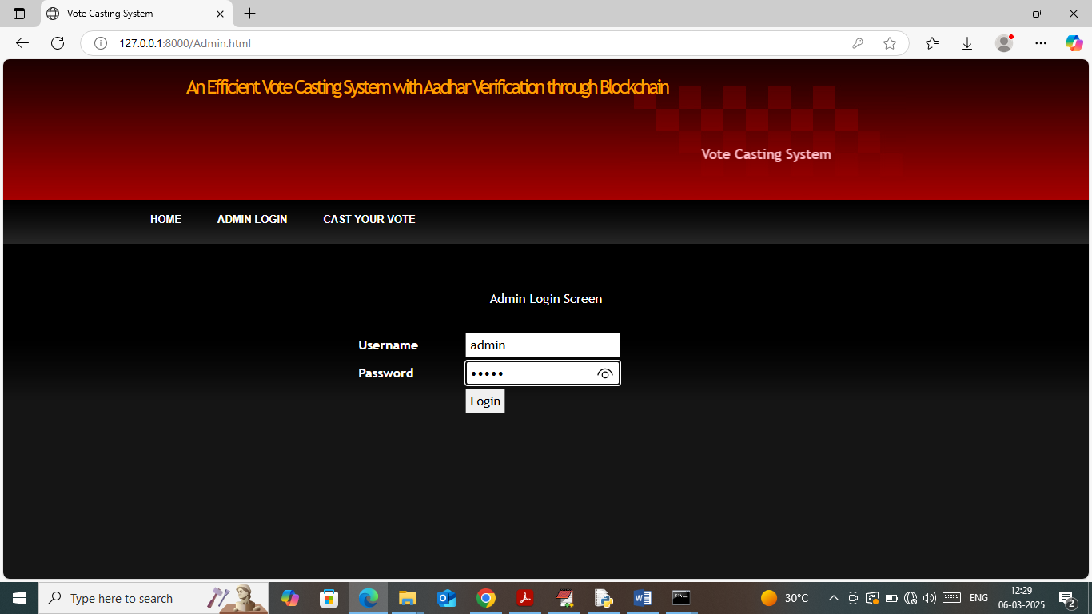
In above screen admin is login and after login will get below page
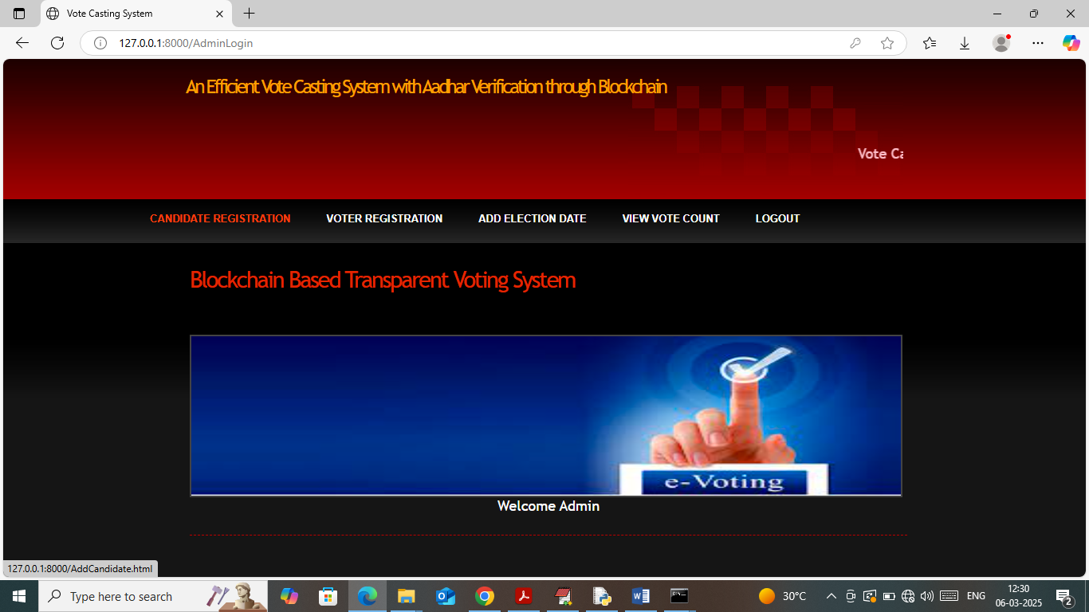
In above screen admin can click on ‘Candidate Registration’ link to add candidate details
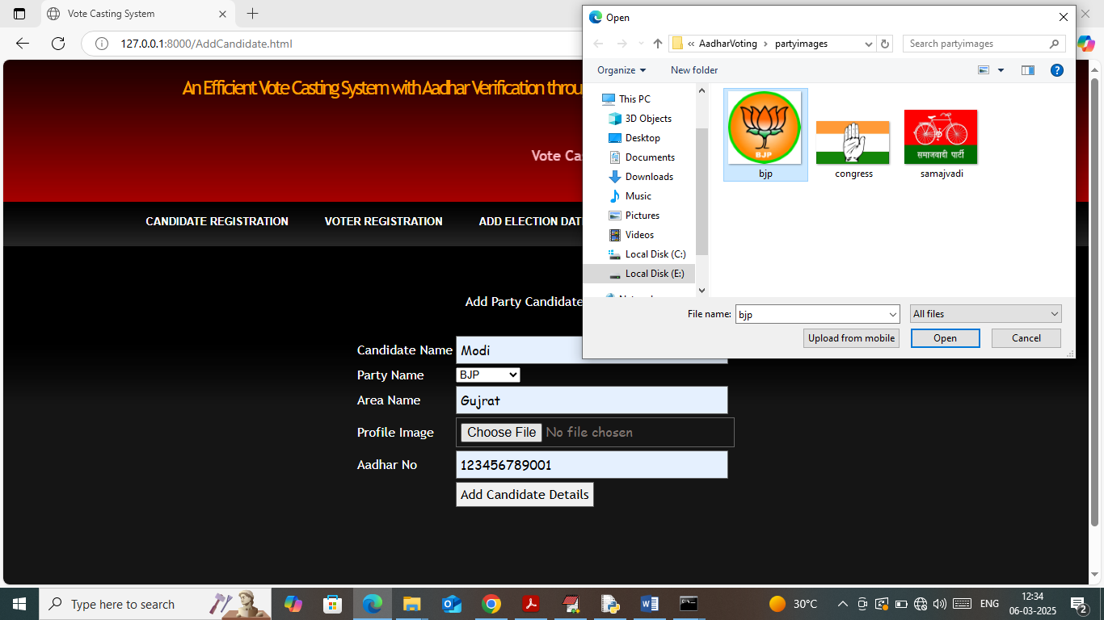
In above screen add candidate details along with party symbols and then press button to get below page
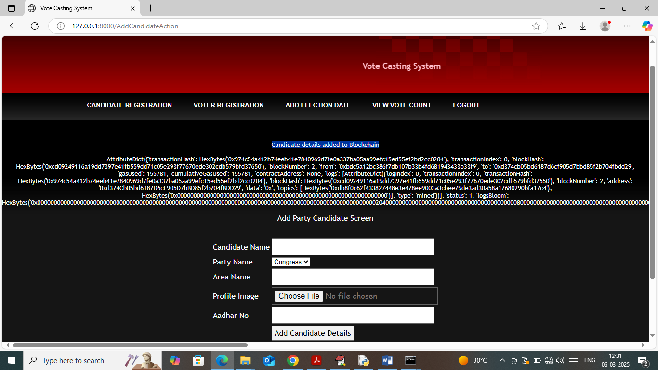
In above screen candidate details added to Blockchain and then in am displaying entire log obtained from Blockchain after data storage. In above log can see details like Transaction no, Block no, block hashcode and many other details. Similarly you can add as many candidates as you want
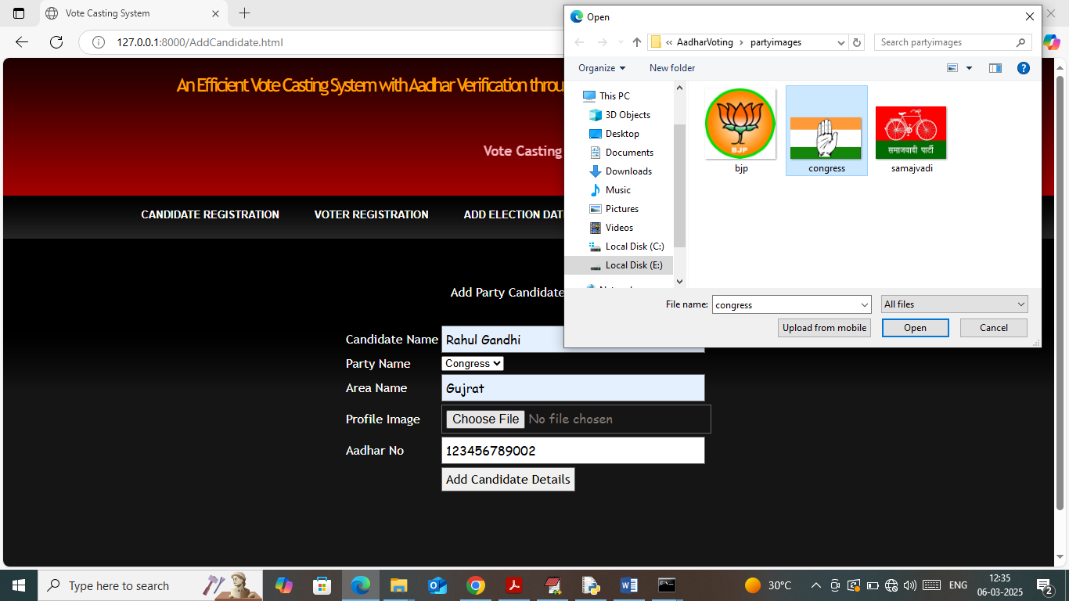
In above screen adding another candidate and now click on ‘Voter Registration’ link to get below page
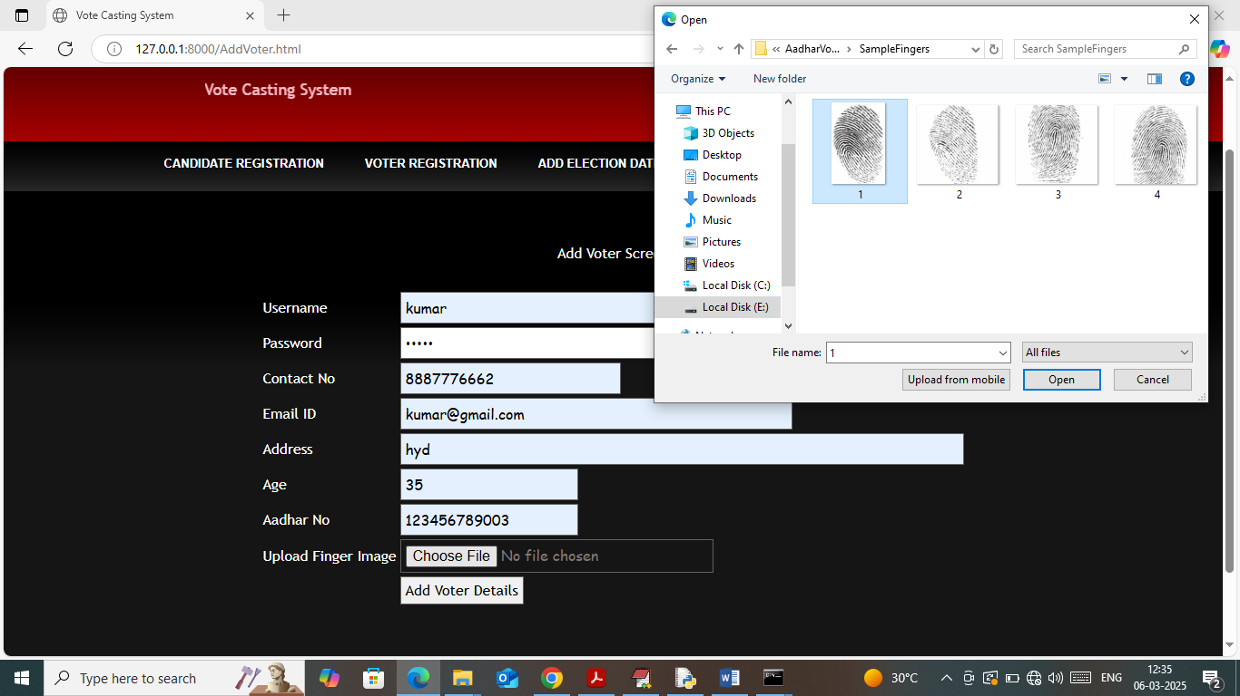
In above screen adding voter details along with Aadhar no and fingerprint and then press button to get below page. (Note we don’t have Aadhar database or fingerprint scanner so we are uploading as image).
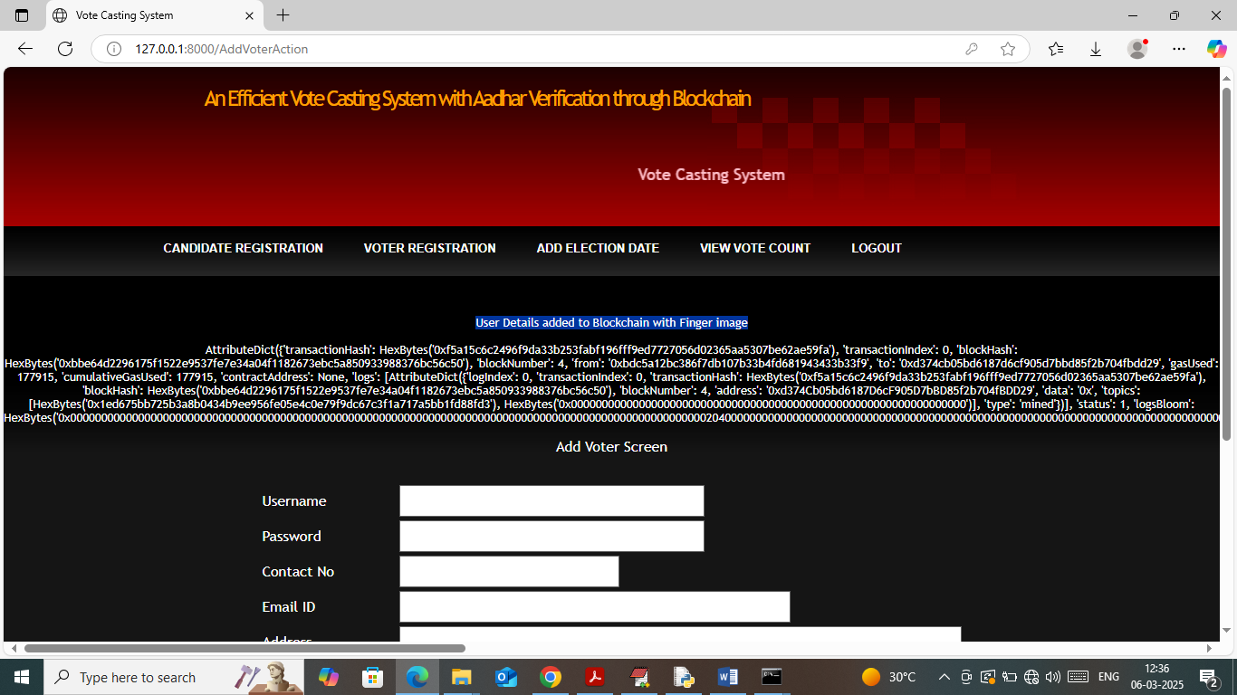
In above screen user details along with fingerprint added to Blockchain and similarly you can add as many voters as you want. Now click on ‘Add Election Date’ link to get below page
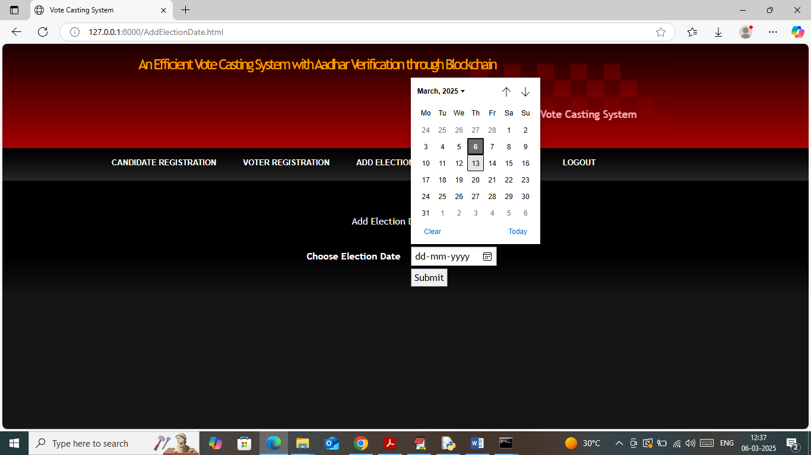
In above screen selecting and adding election date. You can choose any date but today only we have to run all modules so select today date only so voter can login and cast votes. Now click on ‘View Vote Count’ link to get below page
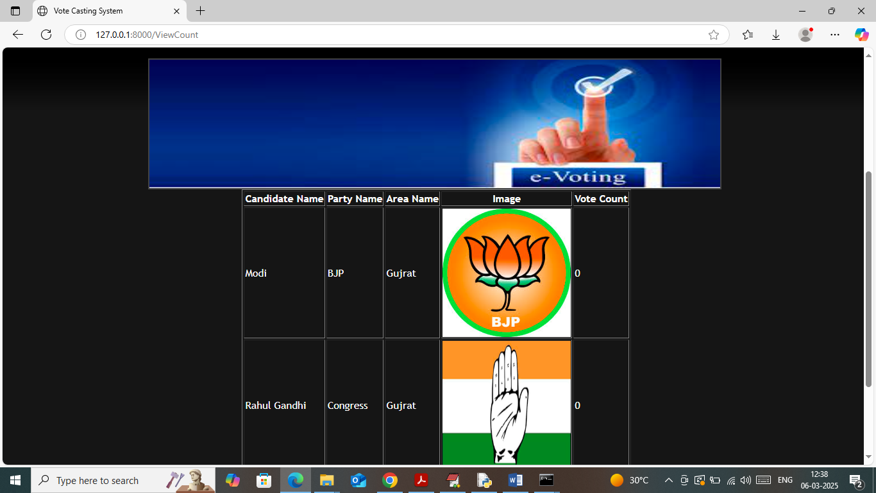
In above screen all candidates has 0 votes as no voter cast any votes yet. Now logout and login as voter to cast vote
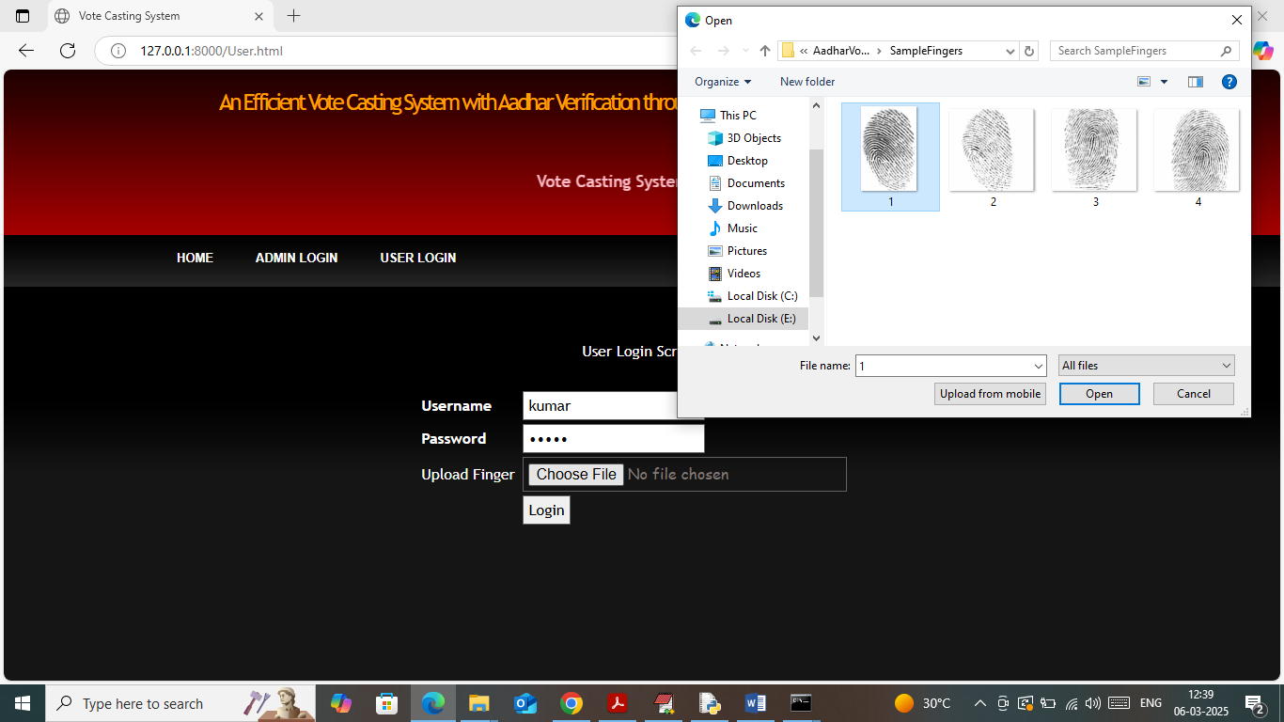
In above screen voter is login along with fingerprint and then Blockchain will authenticate voter finger with cloud database finger and upon successful verification will get below page
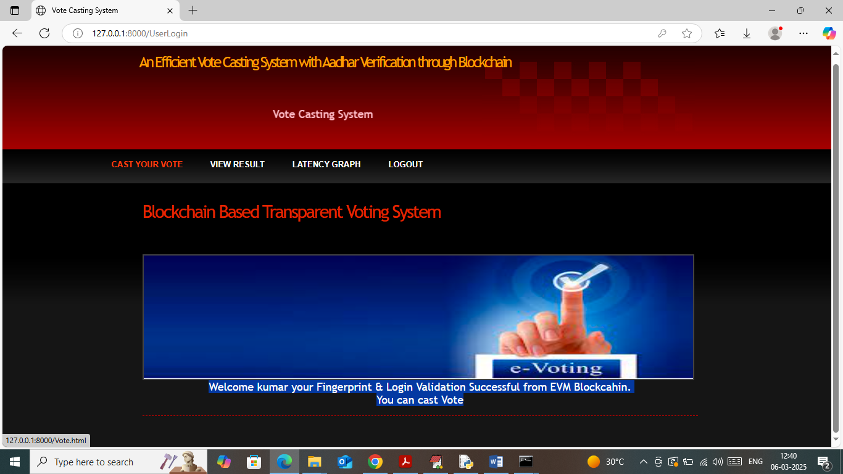
In above screen in blue text can see voter successfully verified and now click on ‘Cast Your Vote’ link to get below page
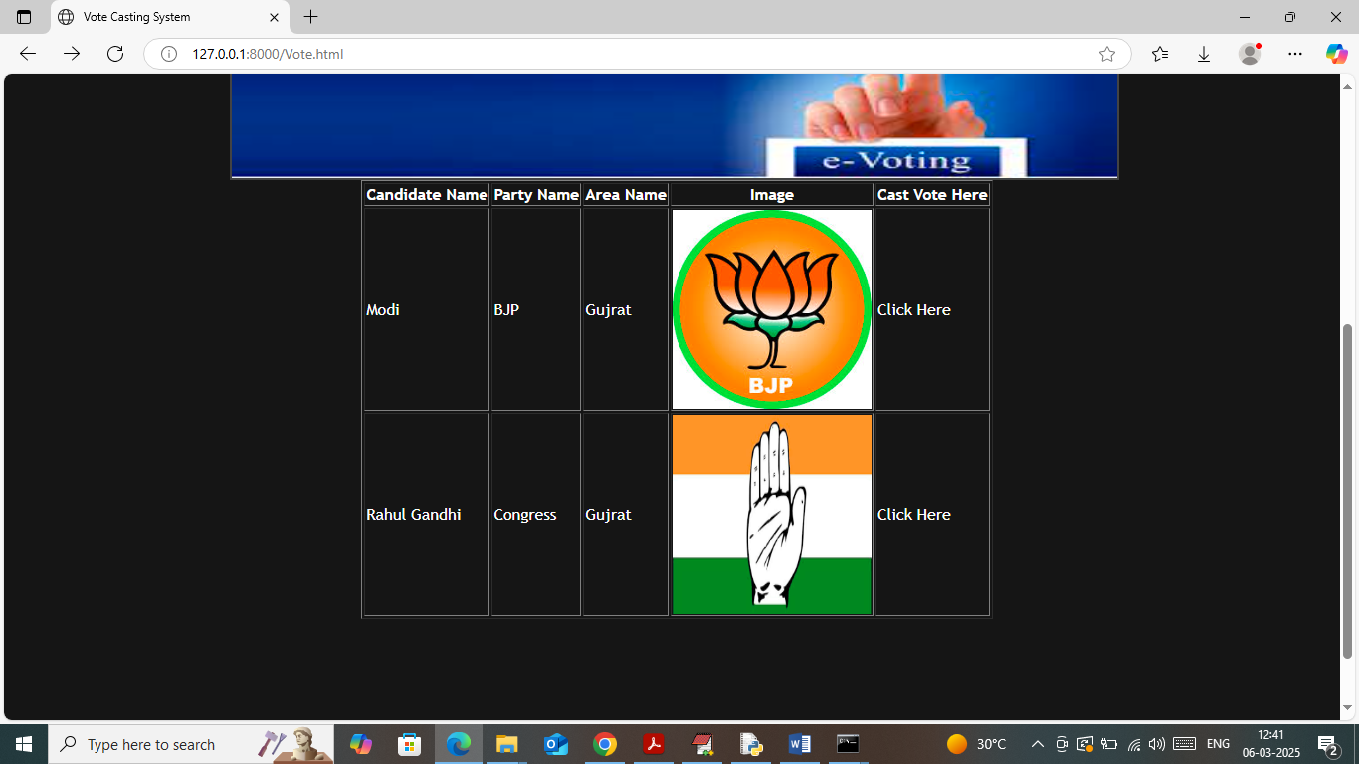
In above screen Voter can see list of candidates and can click on ‘Click Here’ link to cast vote and then will get below page
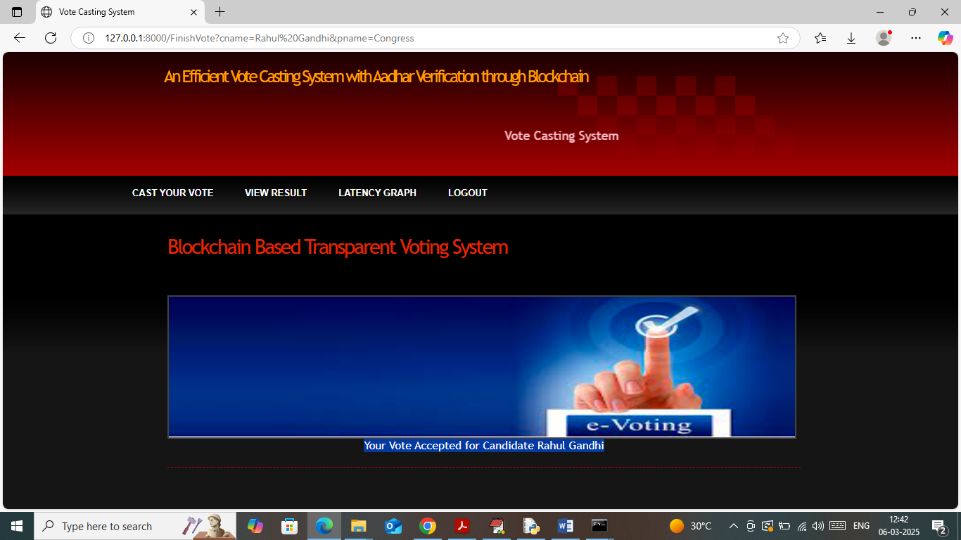
In above screen in blue text can see Voter votes successfully casted to selected candidate. Now click on ‘Latency Graph’ link to get below page
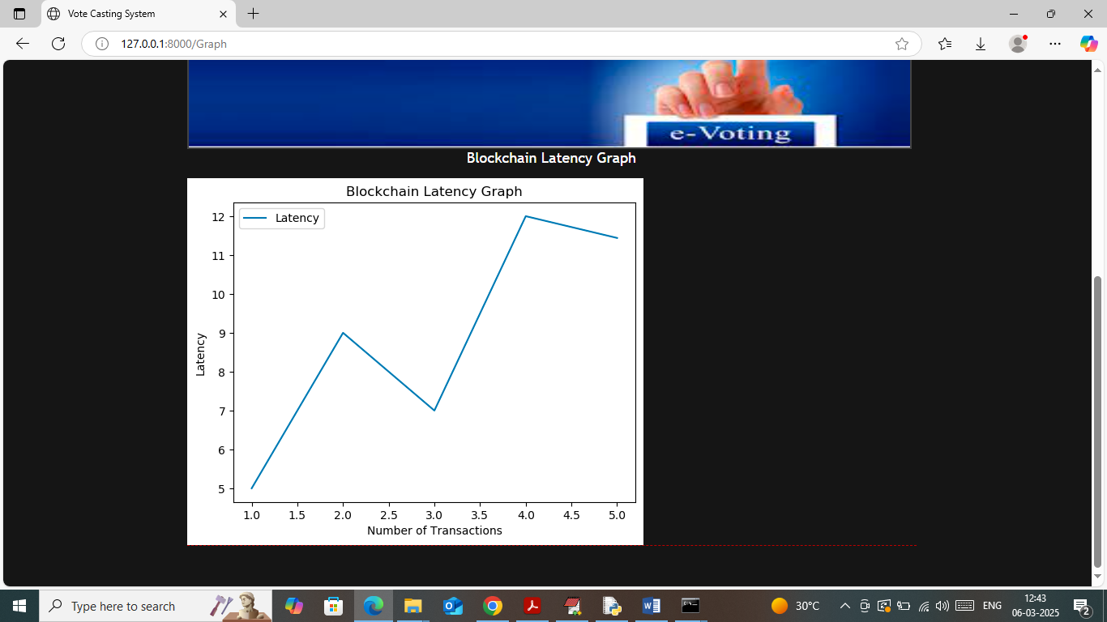
In above graph x-axis represents number of Blockchain transaction an dy-axis represents latency to execute transaction. Now click on ‘View Result’ link to get below page
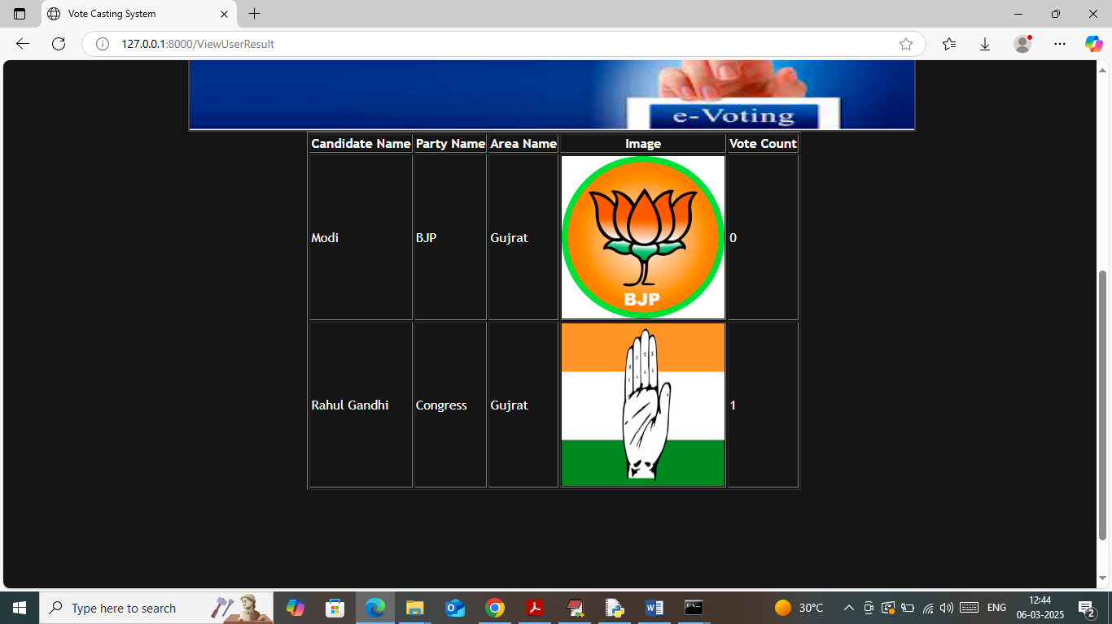
In above screen user can view which candidate got how many number of votes.
Similarly by following above screens you can run project and manage all voting details in Blockchain.

